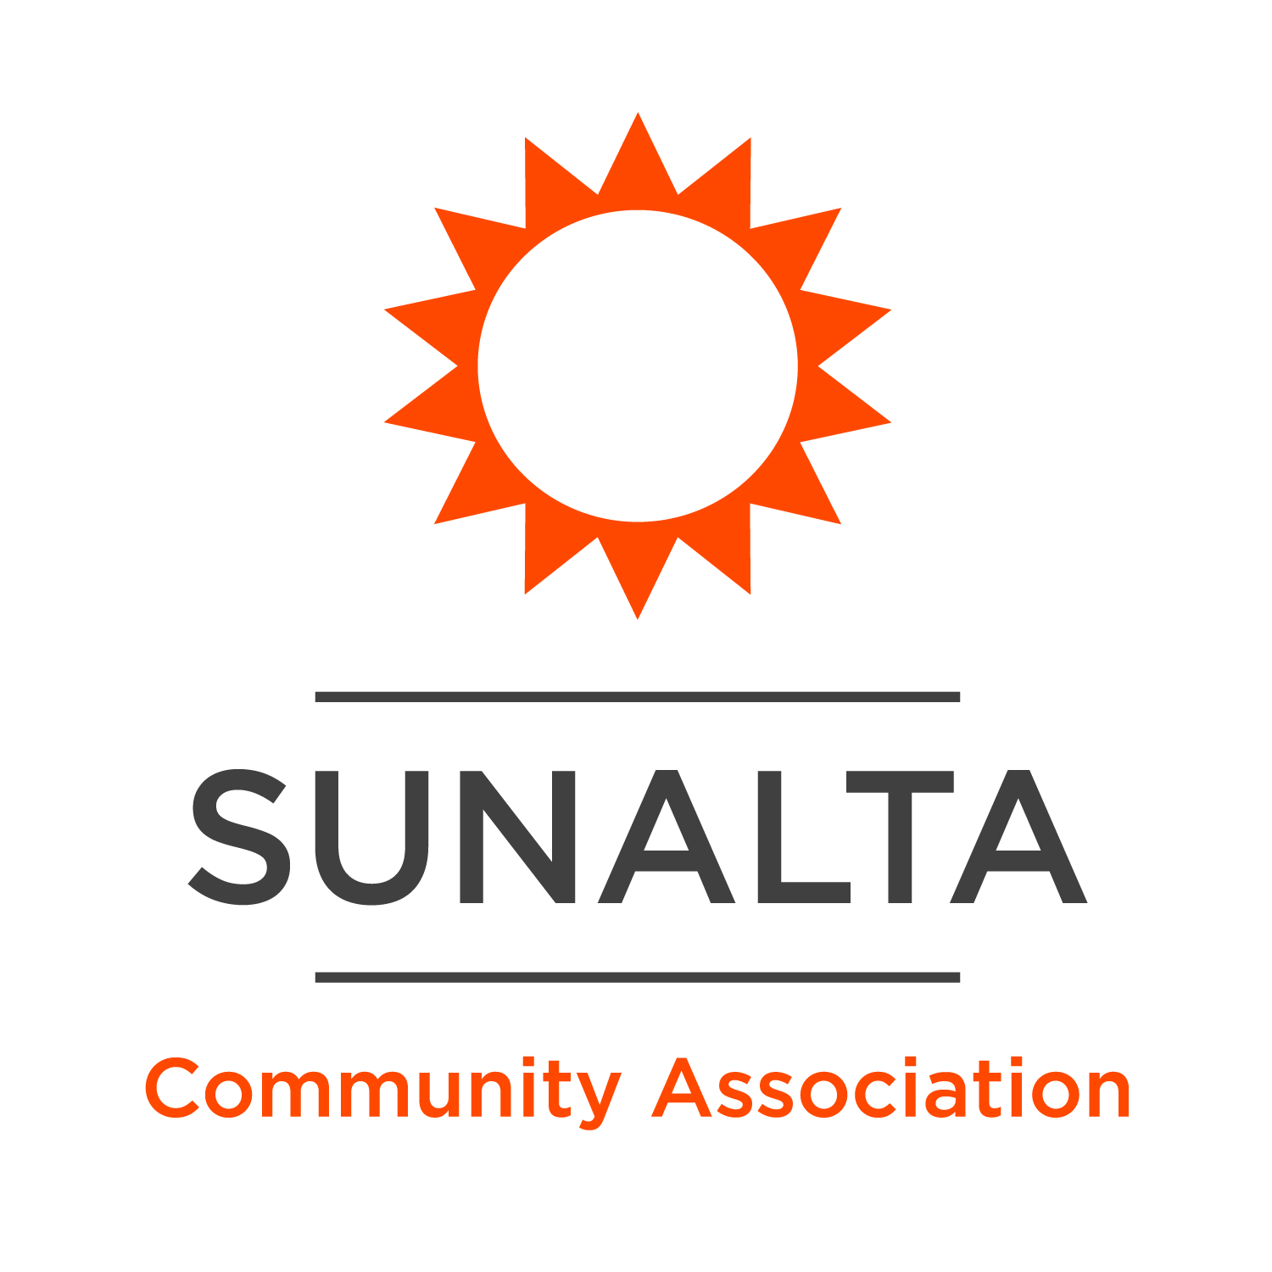

**Operations Manager**

Sunalta Community Association

*Sunalta is a residential neighborhood in the Southwest quadrant of Calgary, Alberta. The Sunalta Community Association (SCA) is actively involved in addressing the concerns of this inner-city neighborhood and currently serves a population of just over four thousand people. The mission of the SCA is to build a build a vibrant, welcoming, and inclusive community. We are removing social isolation, improving food security, doing important community economic development work, and creating a community living room, where everyone is welcome to come together to find support, experience culture, share in conversation and enjoy being neighbourly.*

***Community Hubs Initiative:*** *Sunalta is thrilled to be entering its ninth year as part of the* [*Community Hubs Initiative*](https://calgaryunitedway.org/impact/communities/community-hubs/) *– a partnership between the United Way of Calgary and Area and The City of Calgary, with the Rotary Club of Calgary as a founding partner. Community Hubs are welcoming and inclusive gathering spaces where residents build connections, access supports and services, and work together to identify and respond to community needs, all of which contribute to stronger neighbourhoods. Six Community Hubs serving more than 200,000 Calgarians exist in the communities of Bowness, Greater Forest Lawn, North of McKnight, Village Square, and Sunalta.*

**Hours of Work:** 40 hours/week

**Work Schedule:** This full-time position will include regular office hours and flex-time to account for evening and weekend obligations.

**Reports to:** Director of Operations

**Wage:** $20.00/hour + Annual Health Spending Account + 3 weeks paid vacation

**Position Summary:** The Sunalta Community Association (SCA) operates its existing community hall and new Hub as a social enterprise. When the Hall and Hub aren’t being used for free programs and services, they are rented out to the public. The revenue from facility rentals is then reinvested back into the community to fund free programs and services. Pretty exciting, right? We are looking for an Operations Manager (OM) to oversee this impactful work. The OM will be responsible for renting the SCA’s 4 spaces, keeping occupancy and revenue high to support our work in community. In addition, the OM will be responsible for facility management – overseeing janitorial, maintenance, and supply contractors for the existing Hall, new Hub, and coffee kiosk. The OM will also drive social impact by making our spaces more welcoming, inclusive, and environmentally friendly, all while using our purchasing power to support the local economy. And finally, the OM will have the opportunity to collaborate with SCA staff throughout the year to plan and execute community-building events, programs, and initiatives.

**Responsibilities**

Hall Rentals

* Respond to customer inquiries, conduct hall viewings virtual and in-person, explain rental terms and conditions, and complete Hall Rental Agreements
* Create and manage client accounts within our POS/bookings system; Amilia
* Prepare daily, weekly, & monthly booking schedules for the 4 spaces and ensure bookings are reflected accurately in the shared calendar
* Update several rental communication documents as needed using Adobe
* Financial management: issue invoices and return damage deposits within Amilia.
* Actively seek out and secure new renters to ensure the SCA meets its rental targets
* Complete regular hall inspections to ensure that renters have not damaged the space or left the space in a dirty, un-rentable condition
* Evaluate and make improvements to current rental policies and systems
* Be available for after-hours emergency calls
* Other hall rental tasks may be assigned as necessary and when time allows

Facility Management

* Oversee hall access; regularly update access codes and communicate to regular renters, partners, staff, and upcoming rentals
* Supplies management for the facility and coffee kiosk; keeping track of inventory, making orders, and receiving and putting away supplies/stock
* Regularly maintain the common storage areas to ensure renter items are not stored at the Hall and that the space is clean and accessible
* Oversee and schedule regular hall maintenance, specifically items concerning building safety, cleanliness, and accessibility
* Oversee and schedule the Hall cleaning and liaise with the cleaning company to ensure daily, weekly, quarterly, and annual cleaning tasks are carried out with excellence
* Perform quality control of vendor’s performance – specifically hall maintenance, cleaning, and groundskeeping (i.e. snow removal)
* With the support of the Director of Operations, apply for facility grants to support the upkeep and life cycle replacement of capital assets
* Other facility management tasks may be assigned as necessary and when time allows

Social Impact & Community Development

* Drive strategies to use the SCA’s buying power to support the local economy
* As needed, support SCA staff with the planning and execution of major events and community programs
* Other supporting tasks may be assigned as necessary and when time allows

NOTE: Non-profits are messy! All staff are expected to pitch in and help out with daily chores.

**Qualifications**

* Exceptional customer service skills
* Experience with facility management or program/space rentals
* Experience managing a calendar or booking system
* Strong financial and administrative skills, experience with accounts receivable a must
* Proficiency with Booking Software and the Microsoft Suite required
* Strong business acumen
* Self-starter with an entrepreneurial spirit
* Passionate about building community and welcoming and inclusive spaces

*Please send your application including resume and cover letter before* ***11:59pm on Sunday, January 5th******2025*** *to* [*jenn@sunalta.net*](mailto:jenn@sunalta.net) *with the subject line “Operations Manager”. Only complete applications will be considered.*

*We recognize that all too often, potential candidates don’t apply for a position simply because they don’t hit every single criteria included in the job description—particularly members of underrepresented groups. Whether or not your experience checks off all the boxes on a job posting, we still encourage you to apply to ensure that your application receives a review from our team.*

*The Sunalta Community Association is an equal opportunity employer that is deeply committed to building equitable workplaces that are diverse and inclusive. We actively encourage candidates from all backgrounds and lifestyles to consider us as a future employer. Please contact the hiring Manager should you require accommodations at any point during our interview processes.*