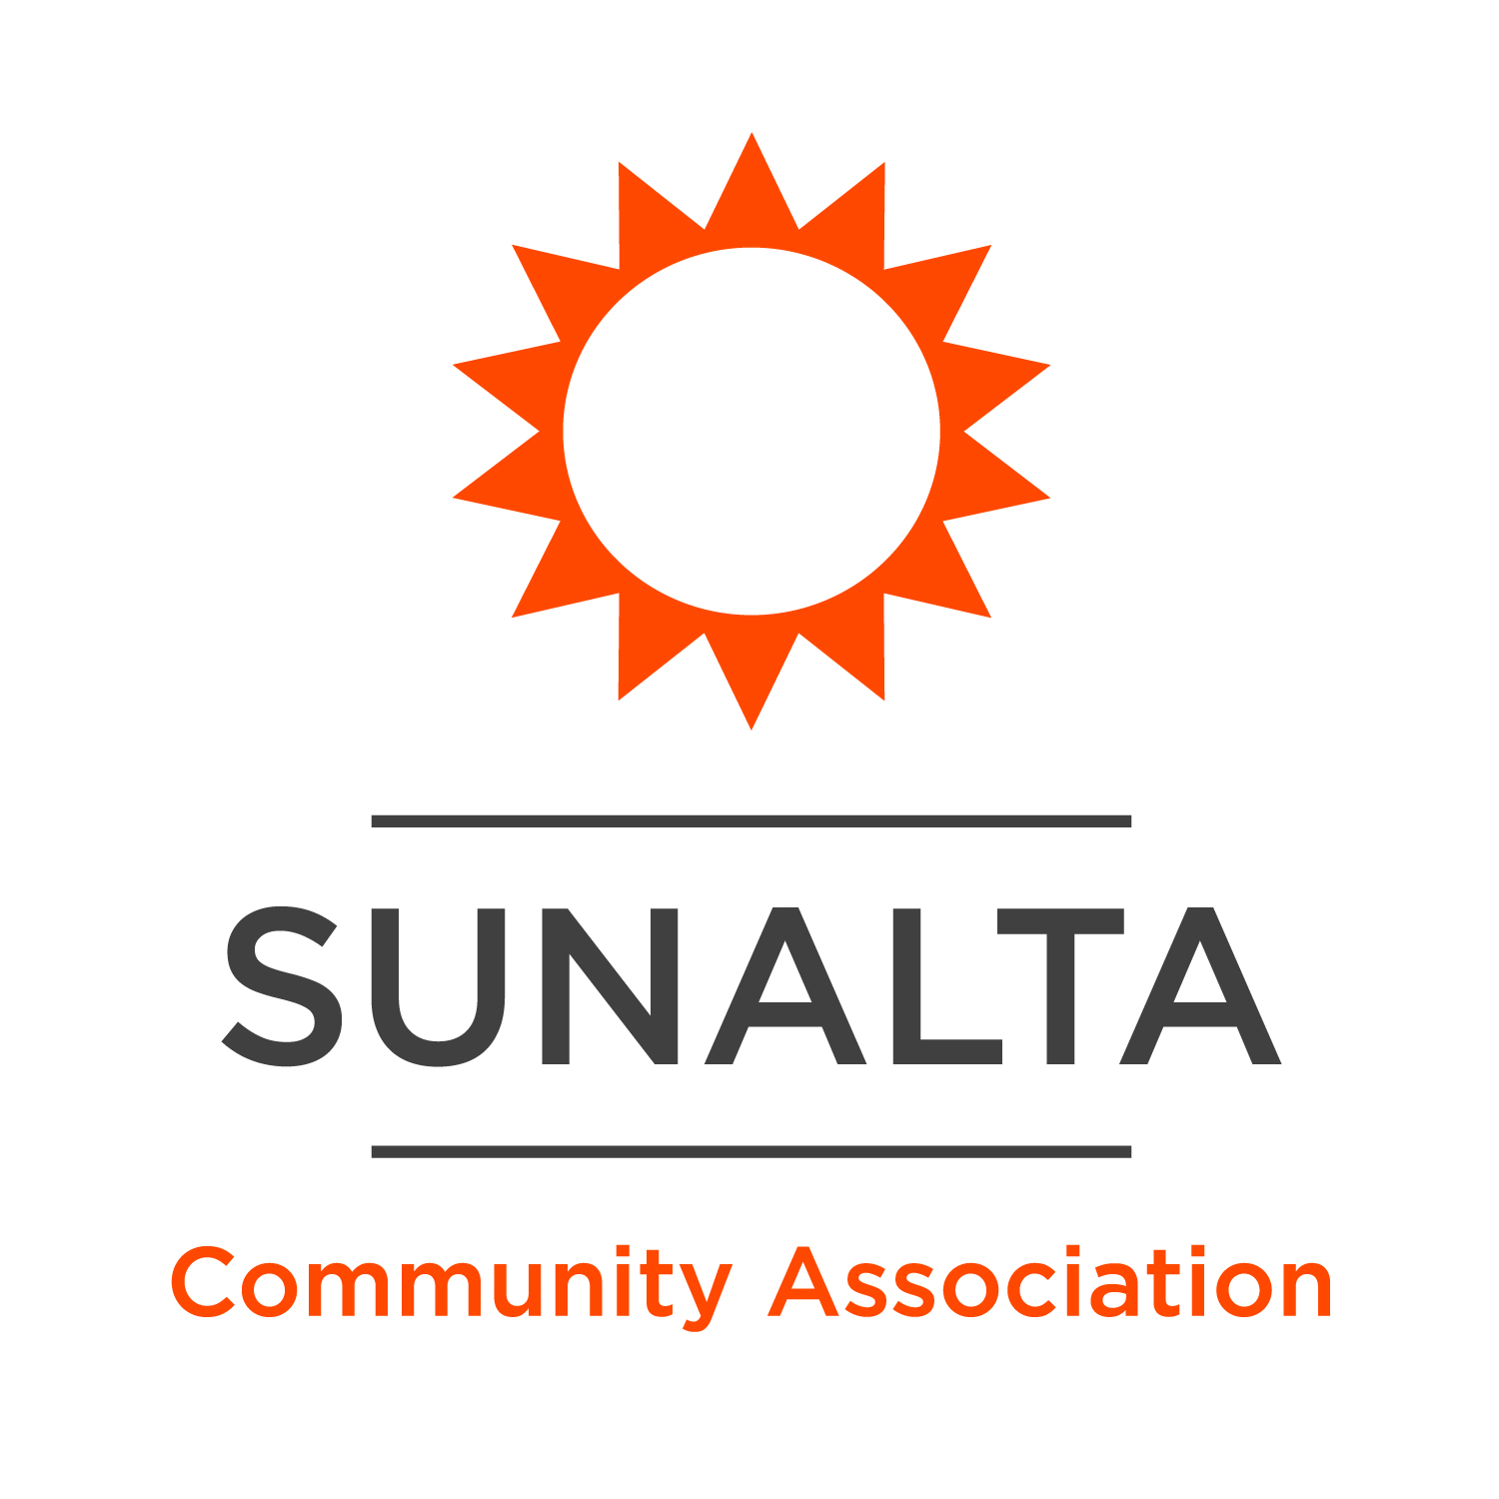

**Barista**

Sunalta Community Association

*Sunalta is a residential neighborhood in the Southwest quadrant of Calgary, Alberta. The Sunalta Community Association (SCA) is actively involved in addressing the concerns of this inner-city neighborhood and currently serves a population of just over four thousand people. The mission of the SCA is to build a build a vibrant, welcoming, and inclusive community. We are removing social isolation, improving food security, doing important community economic development work, and creating a community living room, where everyone is welcome to come together to find support, experience culture, share in conversation and enjoy being neighbourly.*

***Community Hubs Initiative:*** *Sunalta is thrilled to be entering its ninth year as part of the* [*Community Hubs Initiative*](https://calgaryunitedway.org/impact/communities/community-hubs/) *– a partnership between the United Way of Calgary and Area and The City of Calgary, with the Rotary Club of Calgary as a founding partner. Community Hubs are welcoming and inclusive gathering spaces where residents build connections, access supports and services and work together to identify and respond to community needs, all of which contribute to stronger neighbourhoods. Six Community Hubs serving more than 200,000 Calgarians exist in the communities of Bowness, Greater Forest Lawn, North of McKnight, Village Square, and Sunalta.*

**Hours of Work:** 12-16 hours/week

**Work Schedule:** Weekday shifts 6:30am-3pm

**Reports to:** Director of Operations

**Wage:** $18.00/hour

**HSA Spending Account:** $525/year

**Position Summary:** In 2025 we are opening a social enterprise coffee kiosk – where profits will support free programs, events, and services in the community!We are looking for passionate and friendly Baristas to join our team! As a Barista, you will be responsible for creating a warm and welcoming environment, crafting exceptional coffee beverages, and supporting our social enterprise mission. You’ll play a key role in providing excellent customer service, maintaining a clean and organized workspace, and contributing to the overall success of the coffee shop. Love the idea of working for us but have dreams of a career outside of coffee one day? We’ll help you get there! Let us know your future goals during the hiring process and we’ll work together to get you where you want to be! Once you are on your way to your dream career, we’ll rehire and start all over again with another amazing community member!

**Responsibilities**

* **Customer Service:** deliver exceptional customer service – answer questions about menu items, make personalized recommendations, and make everyone feel seen and welcomed into the space.
* **Coffee Preparation:** prepare high-quality espresso-based drinks, pour-over coffees, teas, and other beverages with precision and care.
* **Sales & Cash Handling:** process customer orders, operate the cash register, and handle cash and card payments accurately. Make suggestions to enhance the customer experience and support our fundraising initiatives.
* **Cleaning & Organization:** Keep the coffee bar and seating areas clean, sanitized, and organized throughout your shift. Follow all health and safety guidelines, including food safety and workplace cleanliness.
* **Inventory Management:** restocking coffee beans, milk, pastries, and other supplies as needed.
* **Teamwork:** Work closely with fellow team members to ensure smooth operations and maintain a positive and supportive team environment.
* **Community Engagement:** share the mission and values of the community coffee shop with customers, helping to raise awareness about our social impact initiatives and local partnerships.

**Qualifications**

* Exceptional communication and customer service skills
* Self-starter with an entrepreneurial spirit
* Ability to work in a fast-paced environment while maintaining high standards of quality and customer service
* Passionate about coffee, community, and creating welcoming and inclusive spaces

**How To Apply**

1. Apply online by filling out this [short application form](https://forms.office.com/r/iVRx8CxM9C)! The deadline to apply is 11:59pm on Wednesday, January 15th, 2025.
2. You can also apply in-person starting Monday, January 6 – Wednesday, January 15, 2025. We encourage you to stop by the Hall between the hours of 2-5pm on Wednesdays, Thursdays, or Fridays to apply. When you arrive, please let our staff know that you’d like to talk to Kaylee about the Barista opportunity!

*We will be scheduling interviews as applications come in, so we encourage you to apply as soon as you are ready and not wait until the deadline.*

*We recognize that underemployment is often a contributing factor to some of the challenges facing our community members. Sunalta residents from equity-seeking groups, and/or facing barriers to employment, will be given preference in the hiring process. We’d love to hear more about why this job would make a difference in your life in your application!*

*The Sunalta Community Association is an equal opportunity employer that is deeply committed to building equitable workplaces that are diverse and inclusive. We actively encourage candidates from all backgrounds and lifestyles to consider us as a future employer. Please contact the hiring Manager should you require accommodations at any point during our interview processes.*